Sargent PTO Meeting #5
January 9, 2020
Sargent Auditorium
Meeting Minutes

Principal’s Report

- Request for PTO support for snacks for afterschool tutoring (grades 3-5).
  - In the past the kitchen has provided snacks, but this year we don’t qualify (lower number of children receiving free/reduced lunch).
    - Discussion of the fact that the lunchtime “share bin” is all discarded after lunch, and is there a way to salvage it?
- A proposal for an environmental/green team/club/stipend has been sent to Central.
  - Would support a staff member to supervise kids to organize recycling in the building, help with the educational pieces needed to change behavior, and to outreach for help when needed.
  - Proposal is based on what Rombout did for their new environmental club.
  - Cafeteria has gone back to using plastic utensils because the metal ones were getting thrown out. Mrs. Pagano is looking into replacing metal ones, however.
- Thanks for the star in my head (Penny Wars assembly).
- Thanks to all who contributed to holiday gifts for 8 needy families.
- Great winter concert from band and chorus.
- 27 staff are participating in a “biggest loser” competition for five weeks. See poster at Nurse’s office.
- New hallway mural in basement – walls are prepped. Student drawings are ready.
- Sensory Room got painted over the break. Teacher team will start ordering new items for the room. PTO will help raise the remaining amount needed.
- Mrs. Stickney comes back from parental leave in a few weeks; hoping to keep Mr. Volaski in some capacity.
- Wildfires in Australia – 4th-graders want to do a fundraiser for animals. Ms. Gida and Ms. Guillet supporting them.
  - Parent emphasizes that the need in Australia is for cash, not supplies.
- Sargent is being recognized by the NFL as a “touchdown school”. This is based on healthy food and physical activities. Will receive a helmet signed by a Jets player.

Open Forum

Parent asks about resources available to Sargent on diversity and equity.
- Mr. Archer suggests contacting Assistant Superintendent Erik Wright, who is organizing equity training for district. This is the first year of the new plan. Each building has an equity/diversity team. At Sargent the members are: Ms. Lisewski (coordinator), Ms. Forestiere (5th grade), Ms. Cortina (social worker), and Ms. Butler (3rd grade). The focus has been on power dynamics, responsiveness and getting all kids engaged. Hope to engage more teachers in the future. We are looking forward to having more concrete inputs from the District.
- Parent offers to help with implementing tough conversations in the curriculum, points to free resources for teachers from “Teaching Tolerance”. Mr. Archer will connect the parent to teachers.
- Parents raise concern about bullying, discrimination in students’ language.
  - This is against clear school rules, and we say that constantly. A challenge is when it’s not reported to teachers/administrators.
  - There is a BCSD bullying “tip line” (https://www.beaconk12.org/ - right side, scroll down – looks like this:)
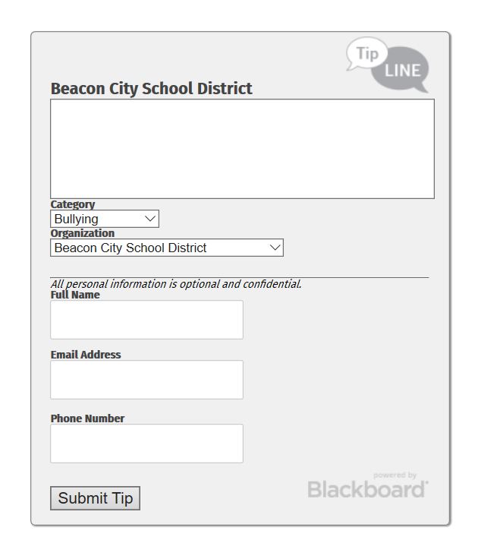
  - Parents suggest setting up a buddy, older mentor system to pair kids at start of each year.
- Parent suggestion of starting sexuality education in 4th grade since kids are talking to each other about these topics (including teasing, bullying) starting at least in 4th grade. There is a locally based young-childhood educator on sexuality topics, and she may already be in conversation with the district.

Fundraisers
- Legacy Tree Planting:
  - Thanks Mr. Archer for being such a good sport and supporting the Penny Wars for the tree. We raised over $1,800.
  - Tree will be planted when ground thaws. Will find as mature a tree as possible – oak or beech. Nurseries are on the lookout for us.
  - Plaque to note that this is a legacy tree from the Sargent Stars in 2019-2020
- Third Annual Trivia Star
  - Thursday, January 16 at Hudson Valley Brewery
  - 54 tickets sold so far. Need to remind staff and get a Sargent headcount for special table.
  - We have about 40 raffle prizes from local businesses.
  - Will send out signup genius for volunteers for day of. Will need folding chairs from the school.
- Coming up:
  - Chipotle is March 18
  - Five Guys April 20
- Mr. Archer suggests setting up a calendar of fundraisers with the Main Office. Could help avoid scheduling overlaps and prevent parents from getting overwhelmed with requests.

Event Planning
- February Family Fun Night. Dance party! [Update on date: Now scheduled for Friday, Feb. 21, 6:30-8:30 pm]
  - Theme – 5th graders voted for the theme ‘Rainforest Rave’. Parent suggestion to put out a donation bucket for the animal fundraiser.
  - Kids have to be supervised. Mr. Archer will reinforce with a robocall.
  - Need volunteers to come to crafting party for decorations (could be at Sargent auditorium) and to show up after school to decorate, run dinner and bake sale.

Committee Updates
- Sensory Room
  - See Principal’s report
- Beautification/Artist Collaborations
  - Joe Pimentel coming Monday Feb. 10 to pick up drawings. Has done measurements. Hallway is prepped. Coming Feb. 18-21 to paint. Presentations with kids to be scheduled.
  - Library:
    - Central gave each school got 4-5K to make spaces more collaborative and foster sensory movement. Sargent chose to focus on the library so everybody can benefit. Got tables that are erasable, reshapable/modular. Three new kinds of chairs.
    - Paula King (interior designer and Sargent parent) had produced a design recommendation for furniture, shelving, etc. and the library has been reconfigured; that vision is coming to life. There are new rugs and shelves. Circulation desk still to be done.
    - Library still needs to be painted.
  - Parent questions and suggestions about
    - Support for students that can’t afford the scholastic books
      - Might be organized by Raquel
    - Incorporating books in next year’s holiday drive for families in need
    - Volunteers to read with kids
      - There is an organization that comes to Sargent; Mr. Archer will connect the parent.
- 5th Grade Parents:
  - 4 people met as a committee in November, agreed on keeping the 5th grade’s special end-of-year event on campus (i.e. picnic, kickball and an ice cream truck). Mr. Archer notes that this seems to be teachers’ inclination as well; allows more time for instruction. The parents have been raising money through a stained-glass fundraiser. Asks how PTO can contribute.
  - Suggestions for raising needed $:
    - PTO board could consider a specific request
    - Link with Bunny Hop, Spring Concert, or a Family Fun Night to set up a raffle, put out a bucket, sell stained glass.
  - Related dates and events to note:
    - 5th grade moving up ceremony – June 23 at 10 am. Preference expressed to hold ceremony at Sargent rather than HS, since the reception could follow at the same location.
      - Discussion of having 4th grade parents work the reception (get drinks and snacks for 36 kids, set up, serve, break down)
    - Camp Sargent (last Family Fun Night) is June 12
    - Field Day is the second-to-last week of the school year
    - Ice Cream Social for all four schools’ 5th grades, organized by PTO Collab.

- Sustainability/Green School
  - Happy about the switch from Styrofoam trays to reusable ones, and from plastic utensils to metal. Now we see the need for help to change habits.
  - Parent discussion about need to change the infrastructure in the cafeteria – the counters are built for taller kids, there is not enough surface area to sort, etc.
  - Hopeful for District some support for a green advisor for the elementary buildings.
  - Need to update the signs. PTO will do this.
  - Parent question about donation bin behind school – accept a range of things, any quality – they sort out whether it is good enough to be donated or should be shredded and recycled.

Assemblies
- New Muse4Tet booked for February 19 – this is for all grades
- Illustrator Deb Lucke for 5th grade – booked for June 3.

Other Matters, Follow-ups, Announcements

- Need to add sanitary product receptacles for girls’ bathrooms near 5th grade. Receptable needs to be in each stall.
  - Mr. Archer will take care of this immediately.
  - Parent suggestions to provide sanitary products in the bathrooms, ie a basket of stuff, since the nurse already has them in her office.
- Auxiliary room next to the elevator upstairs. Some aides would love a mindfulness room.
  - Mr. Archer notes Central is aware of this request. Will ask them where it stands.
- OK for parents to find a piano to donate to Sargent, to replace its current piano? Yes.

Next PTO meeting: Thursday, February 20, 7 pm @ Location TBD

