Sargent PTO Meeting #1
September 24, 2020
Zoom recording
Minutes

In attendance: Erin Giunta, Anna Sullivan, Alena Brown, Brian Archer, Naomi Dankworth, Laura Roan, Megan Eckhart, Meredith, Tracy Bottone, Maria, Johanna Salomon

- Introduction to PTO: “Starting Fresh”

We would like to add members to the PTO Board (the elected ‘organizational team’). Elections in October. If interested, please email sargentpto@gmail.com.

Changes to the PTO: we are changing the requirement of paying dues or making a donation in order to vote, attend meetings, etc.

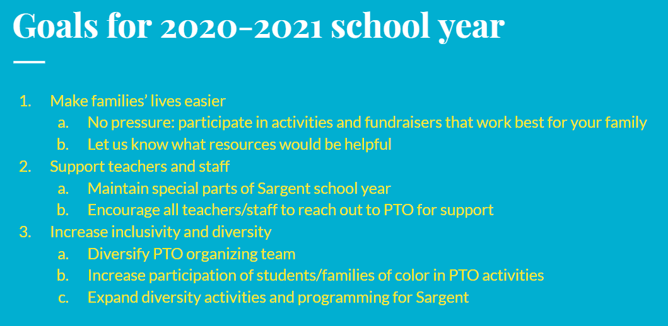

Sign up here to keep updated: http://www.sargentpto.org/

- Principal’s report

- Good opening so far, after all the anxiety to open.
- Update on remote learning: This year’s remote learning is different from in the Spring: taking attendance, expect kids to participate in specials (gym, art, music) when scheduled, want families to have kids conform with schedules that teachers have put together. Attention spans different by age – can’t expect PK or Kindergartner to be on a screen all day. Flexibility. But for Grades 1-5: morning meeting, three blocks of time for ELA, math, and science or social studies, plus a special.
- For chorus and band – October start dates. Mostly virtual.
- Asking families to be patient. A lot of work has already gone into the plans and we are figuring things out as we go.
- Thanks to faculty for tremendous amount of work getting building ready and getting instruction ready for both hybrid and remote. Inspired by what they have been able to do. Thanks to office staff, Meg, Karen, and custodial and grounds staff – everything looks great.
- Numbers: 38% are fully remote (108 kids). 62% are hybrid, Blue or Gold (176 – more blues than gold)
- New staff:
  - First Grade special-ed/self-contained: Erin Card, and assistant Vicky Pennington
  - Reading/AIS assistant: Michelle Glitter
  - Third Grade inclusion: Nicole Prekaris
  - Pre-K: Nicole Panzetta
  - Teacher assistant – 5th grade: Jesse Ligon
  - Teacher assistant: Katelyn Perlongo
  - Permanent sub – Michael Brigetti subbing for Mrs. Cervone
  - Vanessa Black is subbing for Ms. Wokanik
- Arrival/Dismissal is very quick now with fewer families coming each day
- Thanks to PTO for BrainPop – teachers happy to have it.
- We are purchasing Mystery Science Doug with a discount (online science program)
- Safety: everyone wearing masks unless on a mask break or eating/drinking. Kids are great about it, better than some adults. Kids are doing well about social distancing although we still get hugs, which is enjoyable.
- Cleaning throughout the day.
- This only the third day of in-person school, everyone is still establishing routines, and outdoor classrooms not being used as much as I expected. Still getting used to everything.
- State says we still have to do 8 safety drills in the fall and 4 in the spring. Starting soon.
- Discussing a virtual meet-the-teacher night. We’d love to have a live Google meet-up, although sometime parents can’t make it, so maybe a recorded message.
- Still planning to have Student Council and yearbook – put out a request.
- How can PTO support teachers?
  - BrainPop is good
  - Teachers are asking for video cameras for remote teachers. Something we might come to PTO for – not sure yet.
- Sensory room is on hold because of distancing. The room is being used as a remote teaching room right now. The funds are in our budget to continue developing the room. Parent mentions use of individual bags for sensory needs.

- Update on Garden Time

- Megan: We used to be called Hudson Valley Seed, and now we are called Land to Learn.
- We are working out a schedule for in-person garden class as well as remote lessons. Hope to have a version of Garden Time for every student K-2.
- First week of October is possible start date, allowing time/space for teachers to get grounded before making space for Garden Time.
- Email me: megan@landtolearn.org – I will make sure you get the information and the videos directly, don’t have to wait for teachers to forward it to you.
- Great that Sargent already has a space for outdoor learning – teachers can use my materials in the space when I am not there. One teacher already expressed excitement to use the garden.

- Input/suggestions from teachers: Mr. Edsforth (music/band):

- Hope to be more involved with PTO this year.
- I have been cleaning our entire stock of instruments and we are ready to get them into students’ hands.
- Request to pay for 5th graders’ instruments’ reeds. Cases, neck straps, other equipment would be great too periodically during the year.
- Parents of 4th graders might be wondering about band program. It is proceeding. Starts later in the fall.
- I have lots of ideas for this year, new ways to engage with technology and keep growing as musicians.

- Updates from PTO

  - Spirit of Beacon Day Parade – 4 caravans through sections of Beacon. One is for Sargent. Let us know if you’d like to join your car.
  - Spirit Wear – switching to online ordering period
  - Fall photos (Lifetouch) – Working on setting a date. Will happen in cafeteria or auditorium. Will figure out how it works with remote students. Info coming soon.
  - Chipotle fundraiser will be on Wednesday Oct 21st, 5-9pm. – Percentage of your purchase goes back to Sargent.
  - Other fundraisers: Don’t want to be “overfundraising” at any one time. We will give you a schedule so you have heads up and can decide about participating in any of them. Also want you to get something back when you participate (ie food ) FYI 100% of money we raise from fundraisers are put back into our school to enhance school programs for the benefit of all of our children and teachers.
  - PTO Board elections: Open VP seat. Please let us know if you are interested. Will vote in October. We welcome all help – create a role, be in charge of something, any ideas – we want your voices and help!
  - Racial justice: Everyone’s voice is equal here, we want and need more perspectives. Want participation to have value for everyone that participates. We are changing our structure to remove any obstacles to getting involved, get more people in the room/on the screen/at the table. Want to make the PTO more engaging for more people. We can do better and would love help in reaching more people. We want to hear from everybody.
    - Archer: We have a diverse student population – socio-economically as well as racially. Kids get along well, and we treat everyone as fairly as we can, although we are not perfect. Have done a lot of training (“responsive classroom”) including over this past summer. As educators, we need to do better at listening. Sometimes we have to step back and let the kids say what they need to say.
    - Parent question: what do you need help with – what are the plans/ideas for us to help with/expand on?
      - Donate more diverse imagery? Representation so white children see they are not always the center. Would love to help brainstorm ways to support this.
        - Imagery posted in classrooms is widely representative (colors, abilities)
        - Library stocked with books by and about diverse people – working with librarian to see if we can help fill gaps.
    - Parent suggestion: “nothing about us without us” – need to listen to those who are not here right now. Before deciding on spending money. I would help to form a focus group.
    - Parent suggestion: crayons for different skin colors (multicultural crayons). Multicultural and racial diversity is what makes us love Beacon.
    - Land to Learn suggestion: In new remote modes, many families are much more accessible. We are going to engage a family that owns a restaurant to create a cooking video – instead of me teaching how to make salsa we can tap into their family traditions over generations.
  - Community conversations with therapists: virtual talks, guided session, how to talk to your kids about XYZ – send us your ideas for topics or speakers.

Other topics:
- Parent suggestion about Mutual Aid Beacon – mentoring and tutoring opportunities. Let Laura know if interested in being a resource. laurakroan@gmail.com
  - Mr. Edsforth re: tutoring between older student musicians – role models, celebrating diversity, mentoring.
  - How about a free concert with Beacon musicians from diverse cultures – help normalize it and not be so foreign but “normal American life.” Edsforth.o@beaconk12.org

*

Need to reach out:

- Interest in outdoor events
- Topics for virtual talks
- Ideas on racial justice

Other info provided by Mr. Archer before the meeting:

- Playground is not open on Wednesdays so kids coming in for services can use it.
- Girls on the Run, other groups can’t use the school grounds after school yet. Just after-school program through Beacon Rec.
- Library books: Ms. Ferrara is working on getting hybrid students to check out books.
- Morning news: Ms. Ferrara and Mr. Archer are working on options

